Khwopa Engineering College
i sEMESTER ASSESSMENT - 2011 (ODD)
lEVEL:- B. E. (Computer/Elx. & Comm.) I/I
SUBJECT:- BEG146ME, Engineering Drawing-I
FULL MARKS:- 40
TIME:- 03:00 hrs. 2068-01-19 PASS MARKS:- 16

- Attempt ALL questions.
- All questions carry marks as indicated in the bracket.

  - Draw a parabola with double ordinate 120 mm and axis 100 mm. [6]
  - The front view of a line, inclined at 30⁰ to the VP is 65mm long. Draw the projection of the line, when it is parallel to and 40mm above the HP, its one end being 30mm in front of the VP. Write the value of the TRUE LENGTH of the line. [6]
  - Draw the FULL SECTIONAL front view, top view and side view of a given object and dimension it completely. [14]
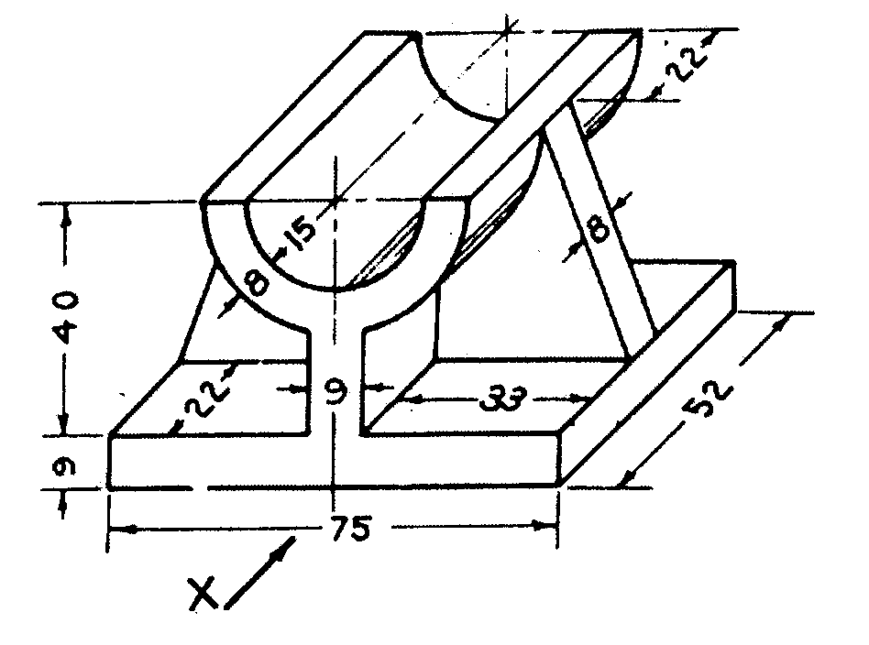

  - Make a complete development of the surfaces of the solid given below, cut by a plane as shown in figure. Find the true shape of the section. [14]




